Environment Setup and Programming Basics

Scene
A Scene is a level or screen in a game.
GameObject
A GameObject is any object in the scene. By default, it has no behavior.
Component
A Component adds functionality to a GameObject.
Script
A Script is a C# file that defines behavior for a GameObject.
Scene View
The Scene View is where developers design and edit the game world. It is used to place objects, adjust positions, and build levels.
Game View
The Game View shows how the game looks when it is running. It represents what the player will actually see during gameplay.
Hierarchy
The Hierarchy displays all GameObjects present in the current scene. It shows parent-child relationships between objects.
Inspector
The Inspector shows detailed information and properties of the selected GameObject. Components, values, and settings can be edited here.
Project Window
The Project Window contains all assets in the project, such as scripts, scenes, images, and materials. It acts like a file manager for the game.
Console
The Console displays messages, warnings, and errors generated by the game. Developers use it to debug code using Debug.Log.
Project Folder Structure
Create the following folders inside Assets:
- Scripts
- Scenes
- Prefabs
- Material
- Animations
This helps keep the project organized.

C# Script Basics
Create a new C# script named GameLogic.cs and add it to an empty GameObject.
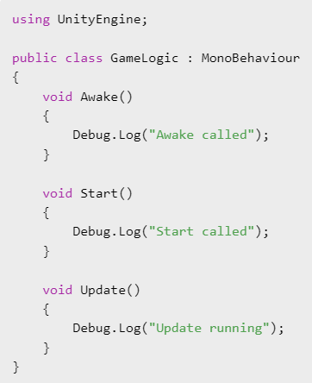

- using UnityEngine; allows access to Unity features
- MonoBehaviour allows the script to run in Unity
- Debug.Log() outputs to the console.
- Awake() runs first
- Start() runs after Awake
- Update() runs every frame after Start.

Taking Input in Unity
What Is Input?
Input is how the player interacts with the game. Unity checks player input repeatedly inside the game loop.
Types of Input
- Keyboard input (W, A, S, D, Space)
- Mouse input (clicks, movement)
- Controller or gamepad input
- Touch input (mobile)

Input.GetKey
Checks if a key is currently being held down.
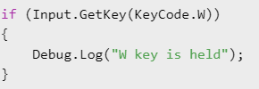
Input.GetKeyDown
Detects when a key is pressed once.
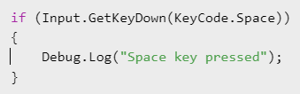
Input.GetAxis
Used for smooth movement input such as horizontal and vertical movement.
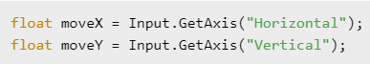
- Input code is usually written inside Update()
- Input is checked every frame

Mini Game Task 1 – Number Guessing Game (Using Input)
Task Description
Create a number guessing game where the player presses keys to make guesses.
Rules
- A secret number is generated at the start
- Player presses number keys (1–5) to guess
- The game checks the guess and prints feedback in the Console
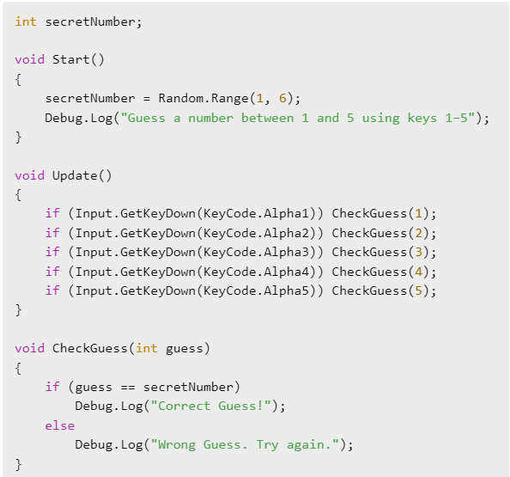

Public: Can be accessed from anywhere and shows in Inspector.
Private: Is only accessed within the class and doesn’t show in Inspector.

SimpleMiniRPG Task 2 – Minimalistic RPG Game
Create a simple turn-based RPG battle in Unity that runs in the console.
- The game has a player and an enemy, each with health = 100 and damage = 10.
- The player attacks by pressing S, dealing a random amount of damage between 0 and 10.
- After the player attacks, the enemy attacks automatically with random damage between 0 and 10.
- The game ends when either the player or enemy reaches 0 health.
- The current health of both characters should be displayed after each attack.
Objective: Learn to use variables, random numbers, functions, and input handling to create a simple battle system in Unity.

using UnityEngine;

public class SimpleMiniRPG : MonoBehaviour
{
// Stats
int playerHealth = 100;
int playerDamage = 10;

int enemyHealth = 100;
int enemyDamage = 10;

void Start()
{
Debug.Log("Mini RPG Battle Start!");
ShowHealth();
Debug.Log("Press S to attack.");
}

void Update()
{
// 1. Check if game has ended
if (playerHealth <= 0 || enemyHealth <= 0) return;

// 2. Player input
if (Input.GetKeyDown(KeyCode.S))
{
// Player attacks
int playerAttack = Random.Range(0, playerDamage + 1);
enemyHealth -= playerAttack;
Debug.Log($"Player attacks! Deals {playerAttack} damage.");

// Check if enemy defeated
if (enemyHealth <= 0)
{
enemyHealth = 0;
ShowHealth();
Debug.Log("Enemy defeated! You win!");
return;
}

// Enemy attacks
int enemyAttack = Random.Range(0, enemyDamage + 1);
playerHealth -= enemyAttack;
Debug.Log($"Enemy attacks! Deals {enemyAttack} damage.");

// Check if player defeated
if (playerHealth <= 0)
{
playerHealth = 0;
ShowHealth();
Debug.Log("You were defeated! Game Over!");
return;
}

// Show current health
ShowHealth();
Debug.Log("Press S to attack again.");
}
}

void ShowHealth()
{
Debug.Log($"Player HP: {playerHealth} | Enemy HP: {enemyHealth}");
}
}

Mini-Project: Console-Based RPG Battle in Unity

Problem Statement
You are tasked with creating a simple turn-based RPG battle system in Unity that runs in the console.
- The game will have a player and an enemy, each with HP (Health) and weapons.
- Both characters can attack with different weapons, and the damage is random up to the weapon’s maximum damage.
- The player chooses their attack each turn, and the enemy attacks automatically.
- The battle ends when either the player or the enemy runs out of HP.
The goal of this mini-project is to practice variables, functions, random numbers, user input, and simple game logic in Unity.

Project Steps

Step 1: Set up Characters
Objective: Create variables for the player and enemy, assign initial values, and print them in the console.
What to do:
- Create a new C# script (SimpleRPG.cs) and attach it to a GameObject.
- Define player and enemy variables: name, HP, maxHP, swordDamage, bowDamage.
- In Start(), assign initial values to all variables.
- Print out player and enemy stats in the console to verify.
Example output:
Battle Start!
Hero HP: 100 | Goblin HP: 80

Step 2: Implement Basic Attack Function
Objective: Create a function to deal damage and update HP.
What to do:
- Write a function like void Attack(string attacker, string defender, int maxDamage).
- Use Random.Range(0, maxDamage + 1) to calculate damage.
- Reduce defender’s HP by that amount.
- Print attack information in the console.
Test:
- Call this function from Start() to simulate a single attack.
- Ensure the HP updates correctly.
Example output:
Hero attacked Goblin with Sword and dealt 15 damage!
Goblin HP: 65

Step 3: Player Input and Turn-Based Logic
Objective: Allow the player to choose their weapon each turn and make the enemy attack automatically.
What to do:
- In Update(), check for player input:
  - S → Sword
  - D → Bow
- After the player attacks, automatically call the enemy attack function.
- Ensure turns alternate between player and enemy.
- Display updated HP after each attack.
Example output:
Your turn! Press S for Sword or D for Bow.
Hero attacked Goblin with Bow and dealt 10 damage!
Goblin attacks Hero with Sword and dealt 8 damage!
Hero HP: 92 | Goblin HP: 70

Step 4: Win/Lose Condition
Objective: Check if the battle has ended and display the winner.
What to do:
- After each attack, check if playerHP <= 0 or enemyHP <= 0.
- Print "You won!" if enemy dies, "You lost!" if player dies.
- Stop further attacks when the game ends.
Example output:
Goblin has been defeated! You won!

After finishing: Allow changing stats from the Inspector instead of hardcoding them.

